

AMALGAMATED TRANSIT UNION

LOCAL 1505

401 - 275 BROADWAY WINNIPEG MANITOBA R3C 4M6 TELEPHONE 204-943-5064 FAX 204-943-5078

**Doubledee A.O.K. Award 2023**

Nomination Form

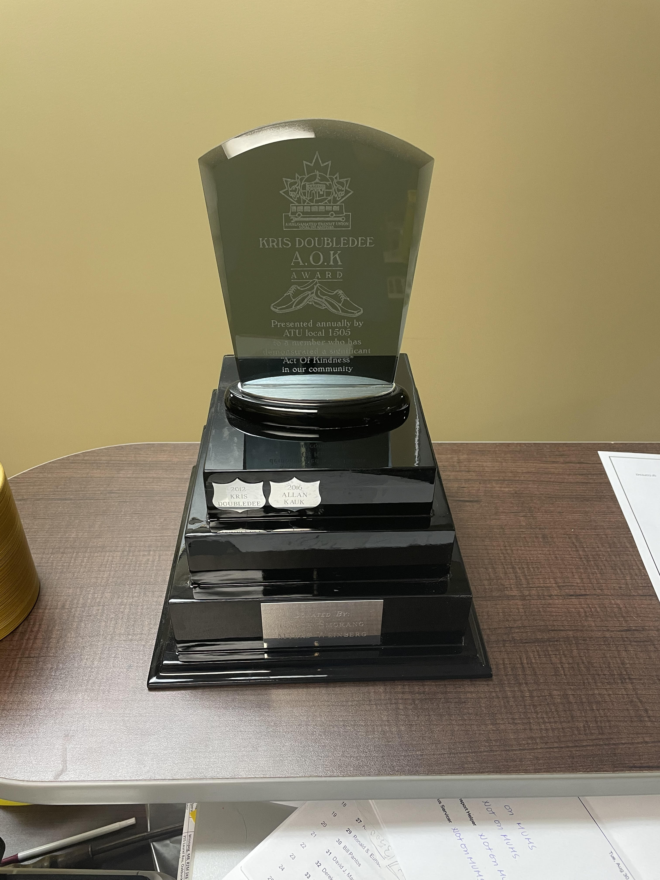The Doubledee A.O.K. (Acts of Kindness) Award recognizes members who have demonstrated an impressive at of kindness at work. The award was inspired by Bus Operator, Kris Doubledee, who gave the shoes he was wearing to someone who was walking barefoot on the cold sidewalk in 2012.

Have you seen one of your co-workers in an act of kindness? Have you been involved in an act of kindness? We would love to hear about it! Nominate someone, or yourself, for the Doubledee A.O.K. award.

Tell us about the situation and the act of kindness by filling out this form. Send the completed form to [office@atu1505.ca](mailto:office@atu1505.ca) or at the ATU Office, 401 – 275 Broadway, Winnipeg, MB, R3C 4M6.

**Nominations must be received by January 31, 2024, to be considered.**

|  |  |  |
| --- | --- | --- |
| **NOMINATIONS** | | |
| YEAR | Name | Department |
| 2022 | Enter first and last name. | Enter what department. |
| Act of Kindness | | |
| Tell us about the act of kindness here: | | |

NG.cope342